# Spring batch

Processing finite amount of data/ batch of data without interaction or interruption

We can restart if that chunk fails

### **When to use spring batch**

If you are handling with huge volume of data then use spring batch – because it can process chunk by chunk

1. Suppose if bank wants to send BE-ALERT messages or current balance mails like our Citibank then use spring batch , because spring batch can fetch person records chunk by chunk and send the messages to the chunk of users-- else u cant send msgs to all people at once, if u do jvm will blast.
2. All the transactions happening under RTGS, NEFT , all the transactions will be stored and executed as a batch.
3. Some vulnerability scanner which will scan bulk files

Use cases:- generation of email statements, weather forecasting reports

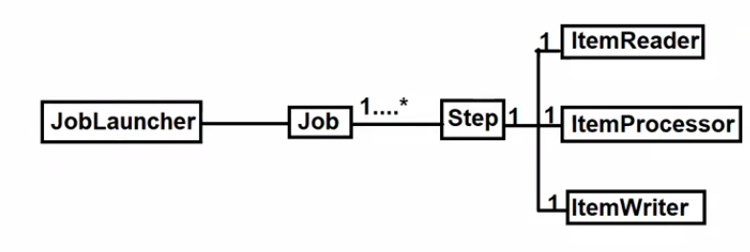

All the job status will be stored in job repository.- jan ran or failed or the status ..

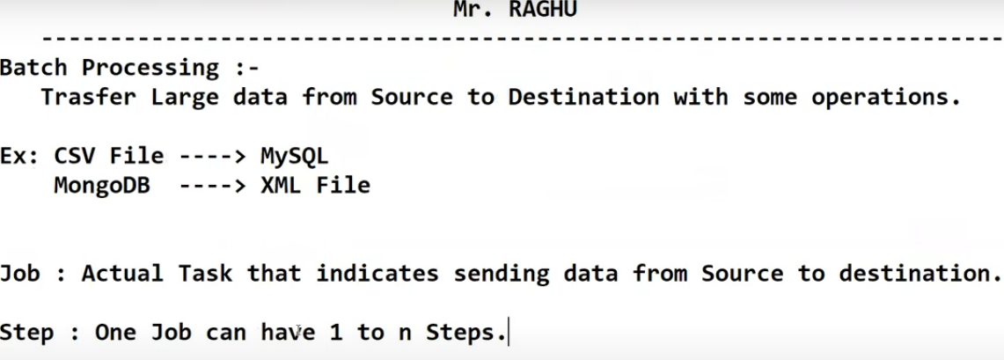

## Job launcher

Job launcher will take inputs from job parameters

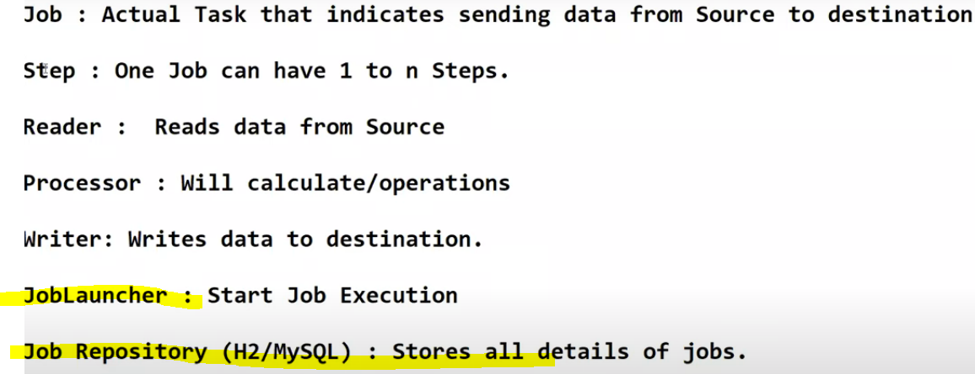

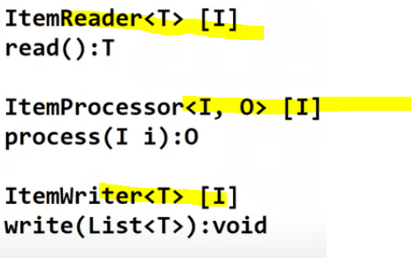all are interfaces

## Item Reader or Item Processor vs Item Writer

Item is nothing but an individual record.

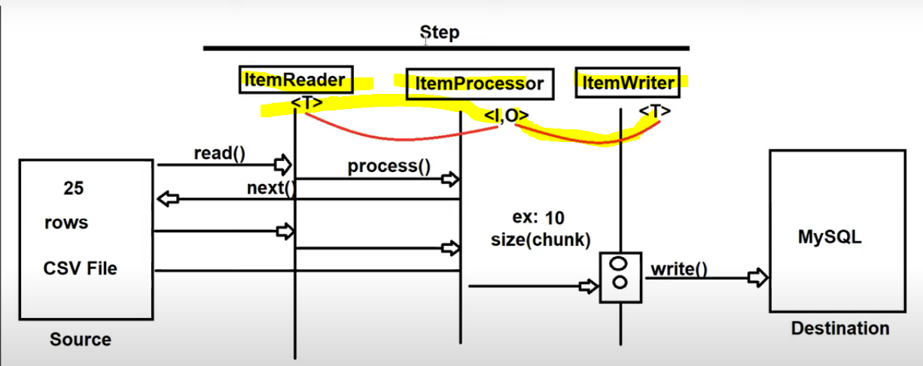

If 25 times reader executed , then 25 times Processor will be executed ,Whereas only 3 times the writer will be executed. Because 25 times the writer should not hit the database, we will mention the chunk size as 10 , only when it has 10 records then it will hit the database.

## Step

Step is an interface created using stepBuilderFactory

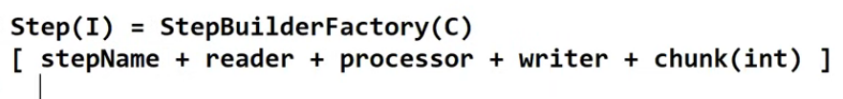

### Chunk oriented step

ItemReader will read the chunk of records at a time from the excel file- means it will read 5/6/some chunk of records at a time from file- here read method will be invoked until chunk size is reached.

ItemProcessor will be called for each and every item present in the chunk

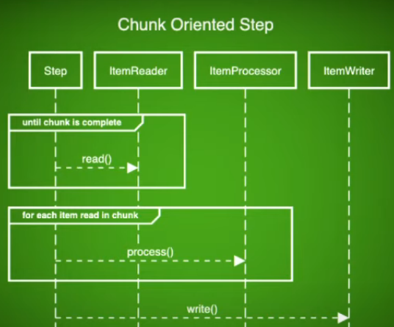

### Job

Think climbing steps Is a job- so that job will have multiple steps, not a single step.

Job is nothing but a process which run from start to finishes without any interuption

Job is also created by job BuilderFactory.

Job is broken up into steps- each step is independent,

Job means lot of steps – like if u want to become IAS officer u have lot of steps

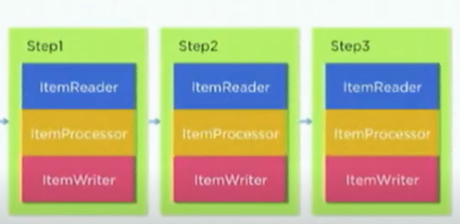



## Full diagram

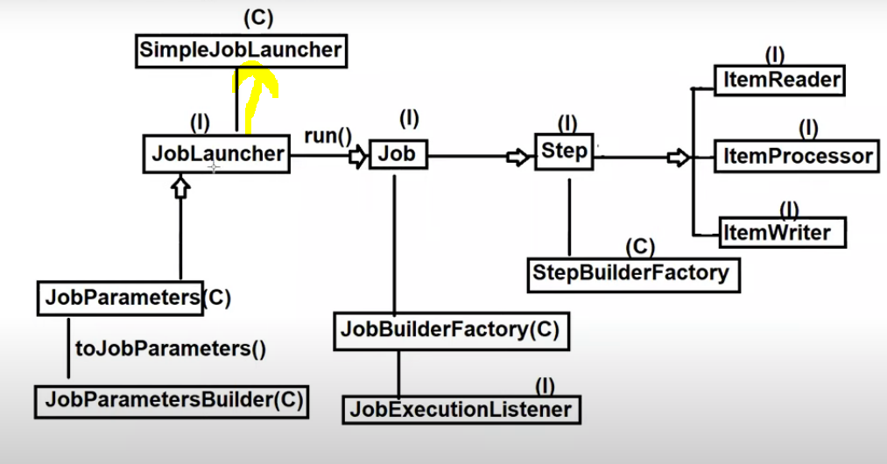

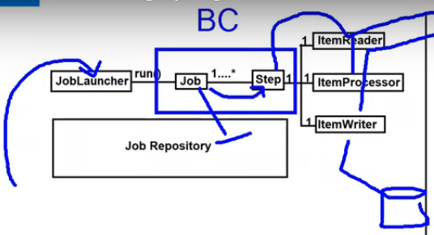

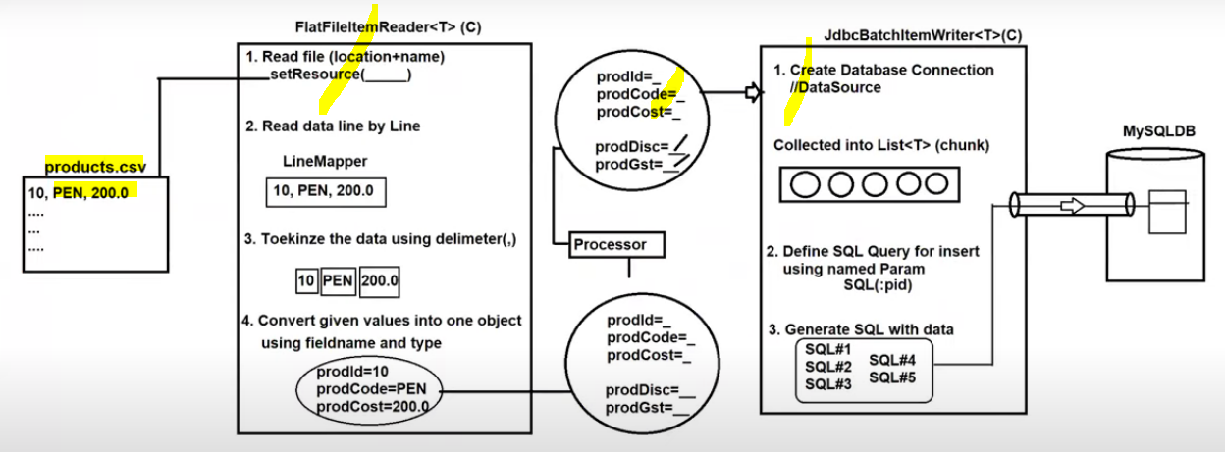

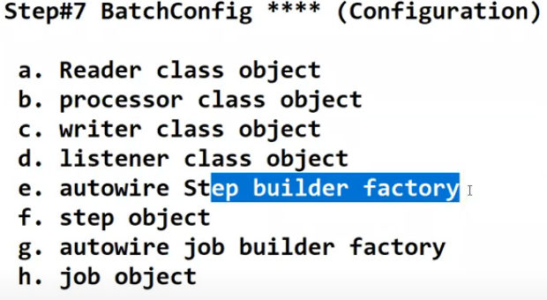

### ItemReader

In most of the scenarios , we will use predefined readers only

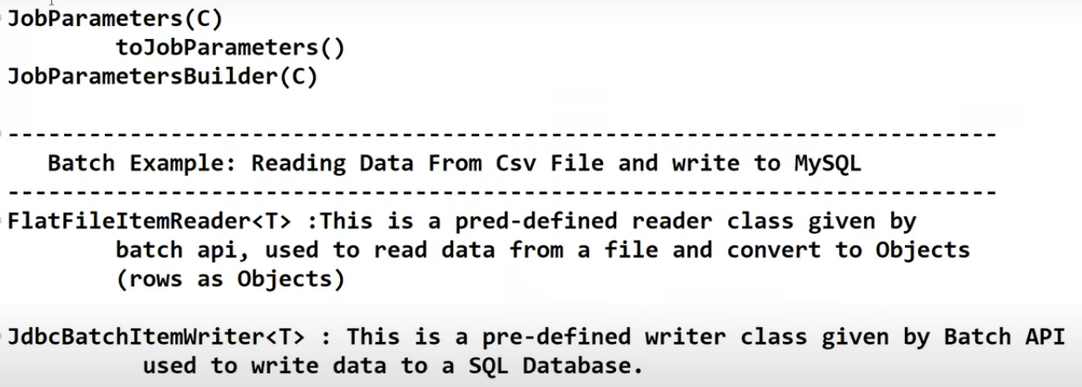

Classpath means src/main/resources

Full diagram

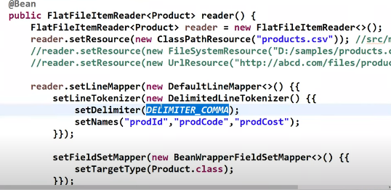

### Detailed ItemReader

Create a line tokenizer object – Break the line and form the fields later map those to a bean.

it says, first split with comma, and consider those fields with these given field names and later map these fields to a bean

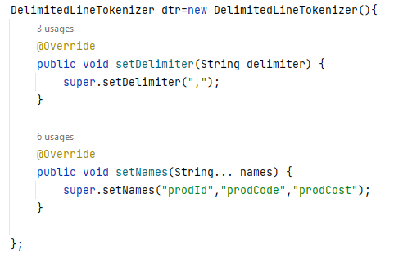

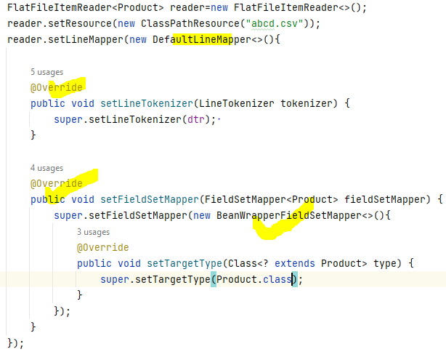

### Program

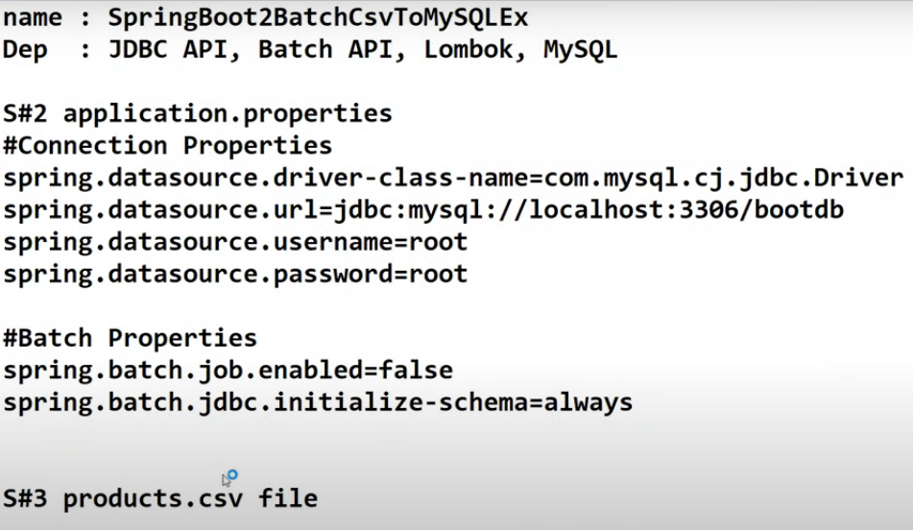

### ItemProcessor

The item processor is going to hold the output until the chunk size is met.

If there is no business logic , u can have a chunk oriented step without item processor.

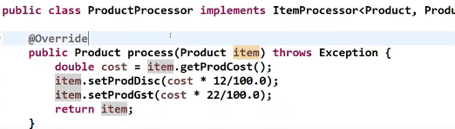

### ItemWriter

Here use predefined writer

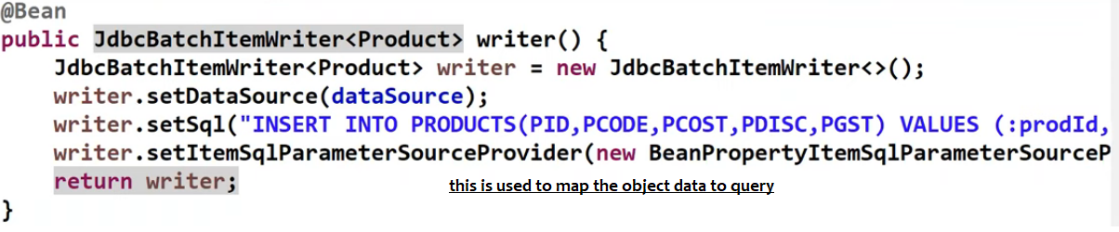

### Step object

#### StepExecutionContext

For each step there will be separate step execution context. And each step execution context data stored in table called dtepeexecution_context

Because each step can have ItemReader , ItemProcessor, ItemWriter with this we can set values in ItemReader and we can fetch in ItemWriter

This is the memory available for that entire step.

This is also a map, which will be stored and is stored in database table

BATCH_STEP_EXECUTION_CONTEXT refer schema-oracle10.sql in spring-batch-core-*.jar all these sql files are present in that jar, dropping the

StepExecutionListener

This will be executed before and after executing the step

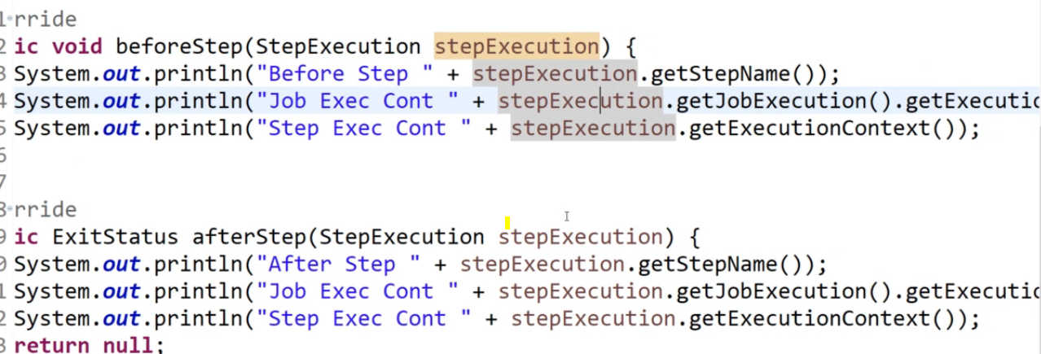

Create step using stepBuilder Factory

Dividing into chunks is mandatory, else memory out of bounds exceptions only, it says how many records u want to process at a time

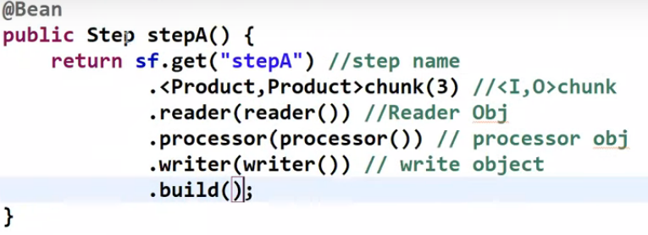

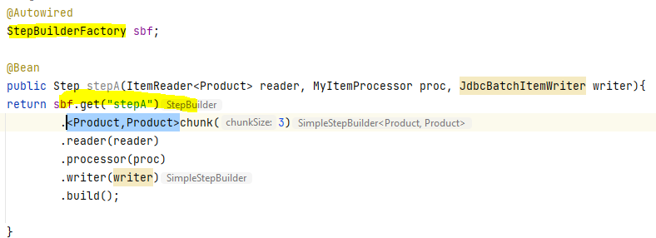

### Job

Here we will configure all the steps

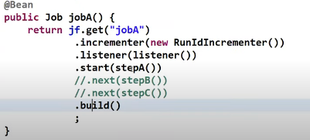

#### JobExecutionContext

This is the memory which is available across all the steps of that job,

Using below, if u set something to jobContext



Then this is available as per above

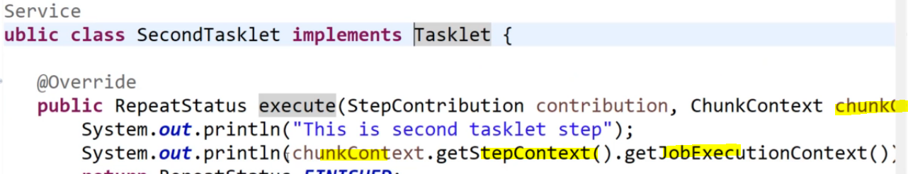

#### JobExecutionListener

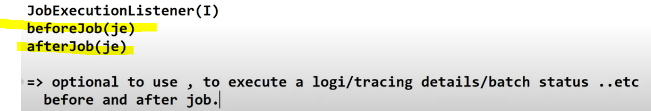

This must be a spring bean , so better mark it as a spring bean, marking is not enough

We need to attach to the job

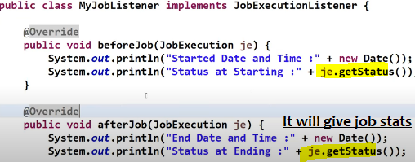

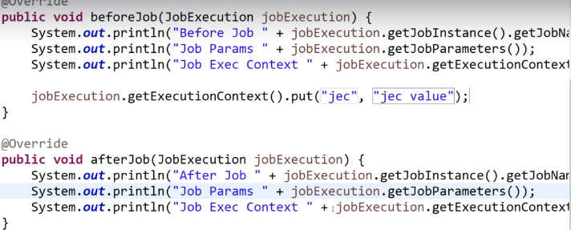

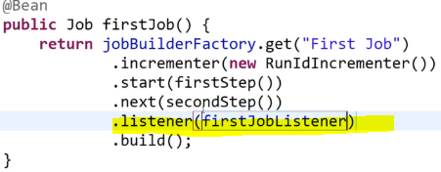

### Run job using jobParametersBuilder

And job parameters is created by job parameterBuilder

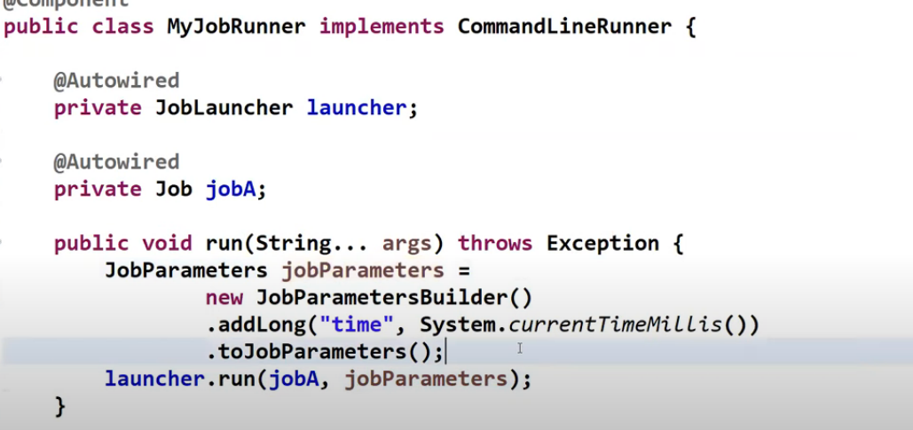

### Testing purpose

Use H2 database and to create a table using below query , if u want that query to be automatically be executed , place that query in src/main/resources/data.sql

create table PRODUCTS (PID INT ,PCODE VARCHAR(20),PCOST DOUBLE,PDISC DOUBLE,PGST DOUBLE );

### Strategy

To process millions of records , we don’t process them all at a time,

We process them in chunks and stores in database

## jobRepository

all the job statuses is maintained in the job repository, so that if any chunk fails , the job can restart from there